Batch: A2 Roll No.: 16010322014
Experiment / assignment / tutorial No. 4
Grade: AA / AB / BB / BC / CC / CD /DD
Signature of the Staff In-charge with date

Title: Configure Layer 3 Switching and Inter-VLAN Routing

Objectives:
Part 1: Configure Layer 3 Switching
Part 2: Configure Inter-VLAN Routing

OUTCOME:
CO 2. Implement enhanced switching technologies and first hop redundancy protocols

Tools required:
Packet Tracer software

Theory:
A multilayer switch like the Cisco Catalyst 3560 is capable of both Layer 2 switching and Layer 3 routing. One of the advantages of using a multilayer switch is this dual functionality. A benefit for a small- to medium-sized company would be the ability to purchase a single multilayer switch instead of separate switching and routing network devices. Capabilities of a multilayer switch include the ability to route from one VLAN to another using multiple switched virtual interfaces (SVIs), as well as the ability to convert a Layer 2 switchport to a Layer 3 interface.

Task:
Topology
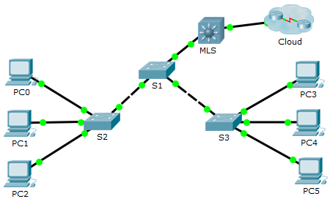

Addressing Table
Device | Interface | IP Address | Subnet Mask
MLS | VLAN 10 | 192.168.10.254 | 255.255.255.0
MLS | VLAN 20 | 192.168.20.254 | 255.255.255.0
MLS | VLAN 30 | 192.168.30.254 | 255.255.255.0
MLS | VLAN 99 | 192.168.99.254 | 255.255.255.0
MLS | G0/2 | 209.165.200.225 | 255.255.255.252
PC0 | NIC | 192.168.10.1 | 255.255.255.0
PC1 | NIC | 192.168.20.1 | 255.255.255.0
PC2 | NIC | 192.168.30.1 | 255.255.255.0
PC3 | NIC | 192.168.10.2 | 255.255.255.0
PC4 | NIC | 192.168.20.2 | 255.255.255.0
PC5 | NIC | 192.168.30.2 | 255.255.255.0
S1 | VLAN 99 | 192.168.99.1 | 255.255.255.0
S2 | VLAN 99 | 192.168.99.2 | 255.255.255.0
S3 | VLAN 99 | 192.168.99.3 | 255.255.255.0

- Configure Layer 3 Switching
In Part 1, you will configure the GigabitEthernet 0/2 port on switch MLS as a routed port and verify that you can ping another Layer 3 address.
      - On MLS, configure G0/2 as a routed port and assign an IP address according to the Addressing Table.
MLS(config)# interface g0/2
MLS(config-if)# no switchport
MLS(config-if)# ip address 209.165.200.225 255.255.255.252
      - Verify connectivity to Cloud by pinging 209.165.200.226.
MLS# ping 209.165.200.226

Type escape sequence to abort.
Sending 5, 100-byte ICMP Echos to 209.165.200.226, timeout is 2 seconds:
!!!!!
Success rate is 100 percent (5/5), round-trip min/avg/max = 0/0/0 ms
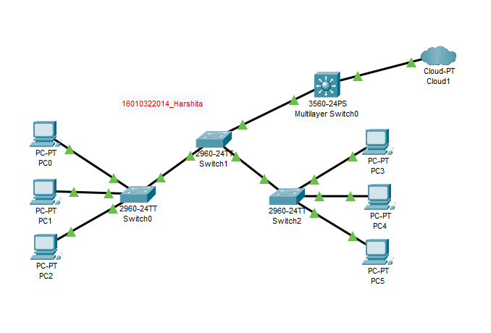

- Configure Inter-VLAN Routing
    - Add VLANs.
Add VLANs to MLS according to the table below.

VLAN Number | VLAN Name
10 | Staff
20 | student
30 | faculty

    - Configure SVI on MLS.
Configure and activate the SVI interface for VLANs 10, 20, 30, and 99 according to the Addressing Table. The configuration for VLAN 10 is shown below.
MLS(config)# interface vlan 10
MLS(config-if)# ip address 192.168.10.254 255.255.255.0

    - Enable routing.
      - Use the show ip route command. Are there any active routes? No.
      - Enter the ip routing command to enable routing in global configuration mode.
MLS(config)# ip routing
      - Use the show ip route command to verify routing is enabled.
MLS# show ip route
Codes: C - connected, S - static, I - IGRP, R - RIP, M - mobile, B - BGP
D - EIGRP, EX - EIGRP external, O - OSPF, IA - OSPF inter area
N1 - OSPF NSSA external type 1, N2 - OSPF NSSA external type 2
E1 - OSPF external type 1, E2 - OSPF external type 2, E - EGP
i - IS-IS, L1 - IS-IS level-1, L2 - IS-IS level-2, ia - IS-IS inter area
* - candidate default, U - per-user static route, o - ODR
P - periodic downloaded static route

Gateway of last resort is not set

C 192.168.10.0/24 is directly connected, Vlan10
C 192.168.20.0/24 is directly connected, Vlan20
C 192.168.30.0/24 is directly connected, Vlan30
C 192.168.99.0/24 is directly connected, Vlan99
209.165.200.0/30 is subnetted, 1 subnets
C 209.165.200.224 is directly connected, GigabitEthernet0/2

    - Verify end-to-end connectivity.
      - From PC0, ping PC3 or MLS to verify connectivity within VLAN 10.
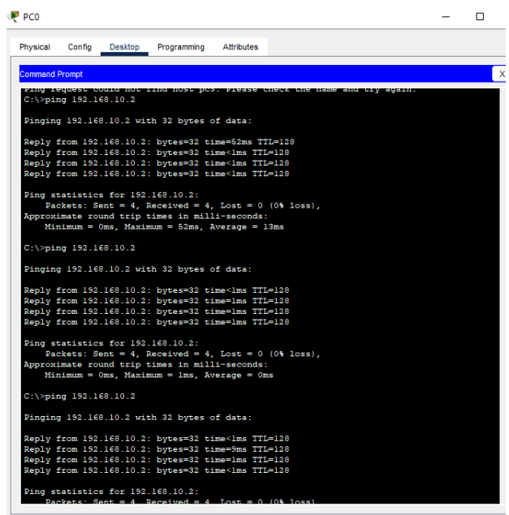

      - From PC1, ping PC4 or MLS to verify connectivity within VLAN 20.
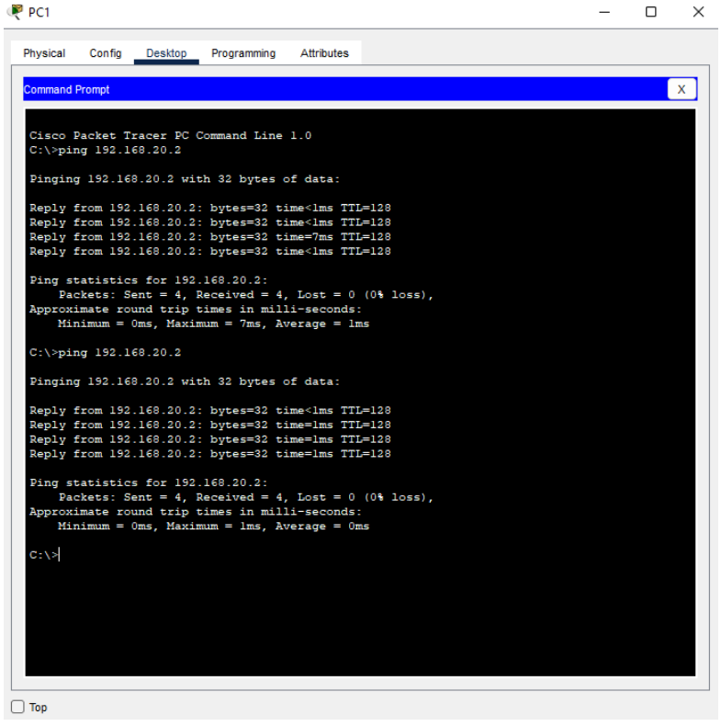

      - From PC2, ping PC5 or MLS to verify connectivity within VLAN 30.

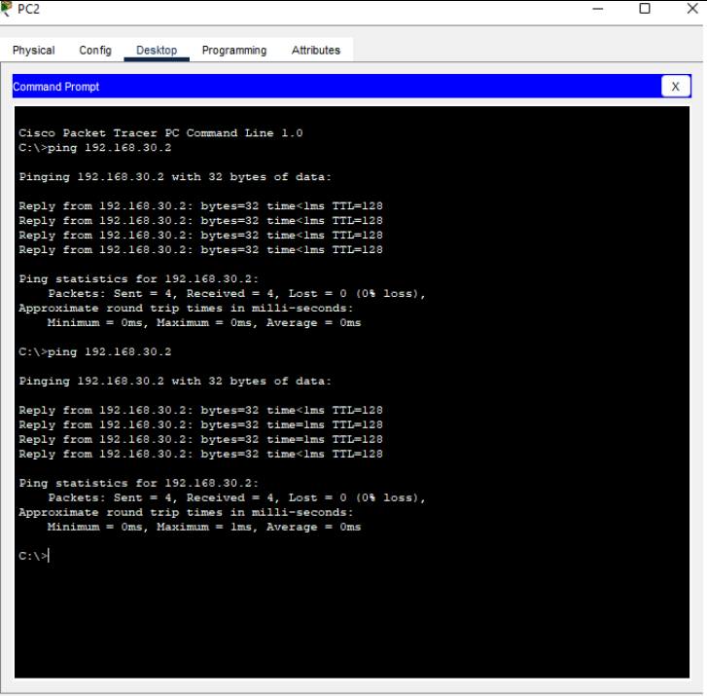

      - From S1, ping S2, S3, or MLS to verify connectivity with VLAN 99.

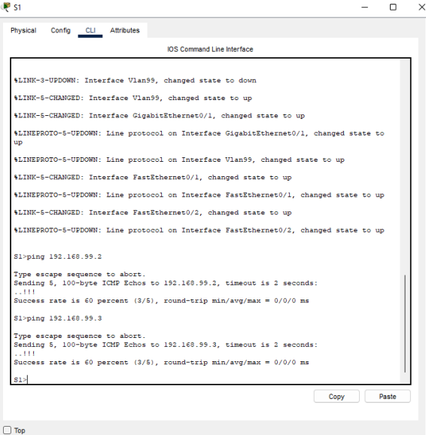

      - To verify inter-VLAN routing, ping devices outside the sender’s VLAN.

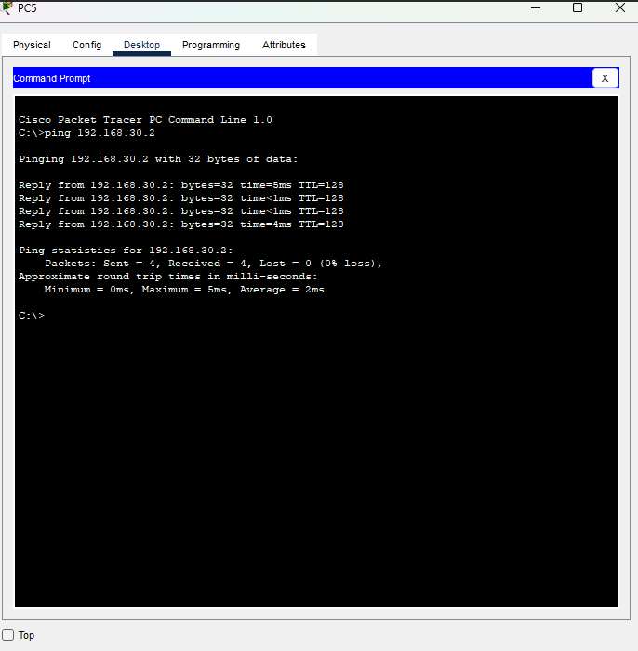

      - From any device, ping this address inside Cloud, 209.165.200.226
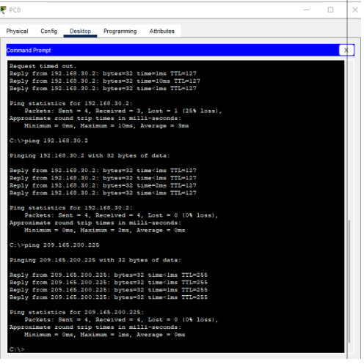
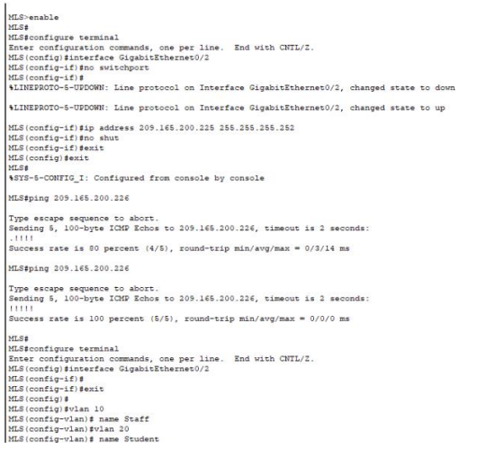

Signature of faculty in-charge

